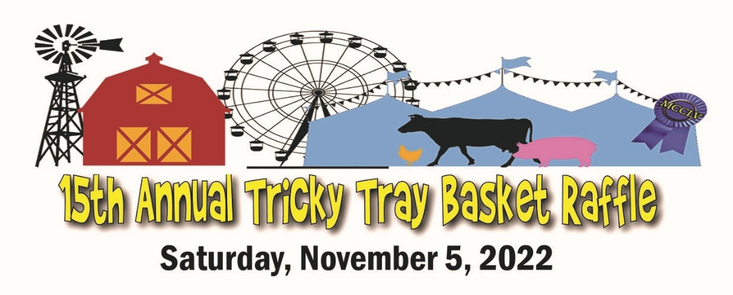

What is the Tricky Tray Basket Raffle?
It is MCCLV’s largest yearly fundraising event. It is a basket raffle where you purchase tickets to “bid” on gift baskets valued from $25 to $500+. Doors open at 9 a.m. when you will purchase your raffle tickets and drop them in the baskets you’d like to win. At noon, we begin drawing the winner of each basket.

Why does MCCLV need to have a fundraiser?
The money from this annual fundraiser goes to support the mission and ministries of MCCLV. Please see the list of MCCLV Outreach Ministries for the church’s local mission projects.

When is the event?
The event is on Saturday, November 5th. Doors open at 9 AM and the prize drawing begins at noon. Plan to arrive by 9 so you will have time to look at all 200 baskets as well as placing your bids. Luncheon will be served from 10:30-12:00.

Where will the event be held?
The event will be held at the American Club of Coplay Pavilion, 300 Cherry Street, Coplay, PA.

How much does it cost to attend?
Tickets to attend the event are $25 and that includes a starter sheet of raffle tickets and a delicious luncheon.

Where do I purchase admission tickets?
Admission tickets will go on sale September 10th. They can be purchased after church each Sunday from September 10 through October 30th in the foyer.

You can also purchase tickets by emailing MCCLVFundraising@MCCLV.info. Please include your contact information so that someone can contact you for payment. Tickets purchased online will be held at the door for the day of the event.

If you purchase a group of 6 or more tickets, you will have a table reserved so that your party can sit together.

How do I obtain raffle tickets?
You will get a starter sheet of raffle tickets with your admission. Additional raffle tickets can be purchased at the event. To purchase raffle tickets the day of event you can use: cash, personal checks (with ID), Visa or Mastercard.

Is outside food allowed to be brought in?
We realize that people with special dietary restrictions often bring their own food to assure that no adverse reactions occur. However, we will be serving a full luncheon with a vegetarian and gluten free option. There will also be a variety of desserts and drinks available. If these options still do not meet your needs, you may certainly bring what works best for you.

PLEASE NOTE: THIS IS A NON-ALCOHOLIC EVENT. ALCOHOLIC BEVERAGES WILL NOT BE CONSUMED DURING THIS EVENT.

Where do the prizes from the prize baskets come from?
Prize baskets are donated from local businesses and from members and friends of the MCCLV community. They range in value from $25 to $500+.

I want to donate a prize basket, but I don’t know where to start for ideas.
You’re in luck! There are plenty of ideas at all price points on the Tricky Tray board located in the church foyer after service each Sunday as well as on the Tricky Tray page of MCCLV’s website (www.mcclv.org).

